**Klickitat Elementary School**

**Title I Schoolwide Plan**

**2012-2013**

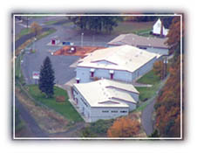

**Table of Contents**

Page

1. Program Planning Team 3
2. Comprehensive Needs Assessment 6
3. Schoolwide Reform Strategies/

Strategies to Ensure Assistance to Students of Need

* 1. Schoolwide Program Goals 27
  2. Instructional Program 28

c. Accountability/ Teacher Participation in Assessment 29 d. Action Plans 31

1. Instruction by Highly Qualified Teachers and 34 Strategies to Attract Highly Qualified Teachers
2. Professional Development 34
3. Parent, Family and Community Participation 34

1. Transition Plans 37
2. Coordination of Federal, State and Local Services 38

Appendices

A. Wednesday PLT’s Afternoon Schedule

B. Klickitat School District Reading Record Grades K-3 Sample

C. Klickitat School District Reading Record Grades 4-6 Sample

D. Klickitat School District Rocket Math Record Grades 1-6 Sample

E STAR Math Student Diagnostic Report K-12 Sample

F. STAR Math Class Summary Report K-12 Sample

G. NWEA MAP Math Grade Report K-12 Sample

H. STAR Reading Student Diagnostic Report K-12 Sample

I. STAR Reading Class Summary Report K-12 Sample

J. NWEA MAP Reading Grade Report K-12 Sample

K. Klickitat School District Writing Rubric

L. Klickitat School District Rank Order Template

**Klickitat Elementary-Secondary School**

**1. Schoolwide Program Planning Team**

**Title I Schoolwide Program Plan**

**Assurances**

The Title I schoolwide program (SWP) option is designed to help facilitate systemic change in the entire educational program of a high-poverty school. The purpose of this systemic change process is to increase the academic achievement of educationally disadvantaged students by providing better services for all students.

The names below certify this Schoolwide Program Plan is in accordance with all applicable Title I rules and regulations.

Jerry Lynch, Superintendent

Kevin Davis, K-12 Principal

Brynn Dawson, K-1st Teacher

Rene Davis, 2nd-3rd Teacher

Nicole Thiemann, 4th-6th Teacher

Laura Bales, K-12 Counselor

**Date of District Review:** January 24, 2013

**Title I Schoolwide Program Plan**

**Date when Plan will be**

**Implemented: 2012-2013 Plan Status: New Revised X**

|  |  |  |  |
| --- | --- | --- | --- |
| **School District Name:** | Klickitat School District | | |
| **Address:** | P.O. Box 37  Klickitat, WA 98628 | | |
|  |  | | |
| **Title I Coordinator** | Jerry Lynch | | |
| **Phone:** | 509-369-4145 | **FAX:** | 509-369-3422 |
| **E-Mail Address:** | jlynch @esd112.wednet.edu | | |
| **Superintendent:** | Jerry Lynch | | |
| **Phone:** | 509-369-4145 | **FAX:** | 509-369-3422 |
| **E-Mail Address:** | jlynch@esd112.wednet.edu | | |
| **Building Name:** | Klickitat School | | |
| **Address:** | PO Box 37  Klickitat, WA 98628 | | |
|  |  | | |
| **Building Principal:** | Kevin Davis | | |
| **Phone:** | 509-369-4145 | **FAX:** | 509-369-4145 |
| **E-Mail Address:** | kdavis@esd112.wednet.edu | | |
| **School Enrollment:**  **Grade Levels:**  **Free/Reduced Lunch %** | 102  K-12  100% |  |  |

**Planning Team**

|  |  |
| --- | --- |
| Parents: | Debbie Pyle  Michele Bautista |
| Certified Staff:  *(include position)* | Brynn Dawson, K-1st Teacher  Rene Davis, 2nd-3rd Teacher  Nicole Thiemann, 4th-6th Teacher  Laura Bales, Counselor |
| Classified Staff:  *(include position)* | Tammy Greenfield, Instructional Assistant  Sandy Hayden, Instructional Assistant  Karen Schlangen, Instructional Assistant |
| Administrators:  *(include position)* | Jerry Lynch, Superintendent  Kevin Davis, K-12 Principal |
| District Staff: | Tammie Huwe, Business Manager |

**Schoolwide Planning Meetings:**

August 28, 2012

September 11, 2012

October 16, 2012

November 13, 2012

January 29, 2013

February 19, 2013

March 19, 2013

April 16, 2013

May 21, 2013

**Technical Assistance/Research**

Technical assistance was provided by: Larry Fazzari, Title 1 Program Supervisor – OSPI, Ann Renschler CPR Program Supervisor – OSPI, Bill Mason O.S.S.S. Director – OSPI, and Barbara Lomas, School Improvement and Professional Development Director – ESD 112. Attendance at regional Title I Directors meetings also provided guidance and information.

|  |  |
| --- | --- |
| **Provider** | **Dates** |
| OSPI | Ann Renschler CPR Program Supervisor: ESD 112 Title 1 Directors Meeting, 10/16/12  Bill Mason O.S.S.S. Director: ESD 112 Title 1 Directors Meeting, 10/16/12  Larry Fazzari Title 1 Program Supervisor: ESD 112 Title 1 Directors Meetings; 10/26/2012 12/5/12 |
| ESD 112 | Barbara Lomas, 10/16/12, 10/26/12, & 12/5/12, Others to be scheduled as needed |
| Title I Directors | 10/16/12, 10/26/12, 12/5/12 Meetings and others to be scheduled at ESD 112 |

**2. Comprehensive Needs Assessment (SWP Component 1)**

This needs assessment is updated yearly by staff and is used for staff and parents to evaluate the impact of the schoolwide program, examine progress made toward reaching the school’s goals and adjust the plan as needed.

**Demographic Data**

There are 25dedicated staff members at Klickitat who sustain the mission and beliefs about education. The 12 certificated staff members represent a blend of styles and experience. The average teacher has 19.7 years of teaching experience and 75% of the staff has at least a Master‘s Degree. In addition, 13classified staff members provide vital services in various roles throughout the school. All classes are taught by staff that meet the NCLB Highly Qualified definition.

The 2012-2013 enrollment at Klickitat School is 102 students K-12. At the present time, the student enrollment is made up of 87% Caucasian, 2% Hispanic, 4% American Indian, and 7% tow or more races represented in the graph below. The percent of students eligible for Free or Reduced lunch in May 2012 was 100% percent.

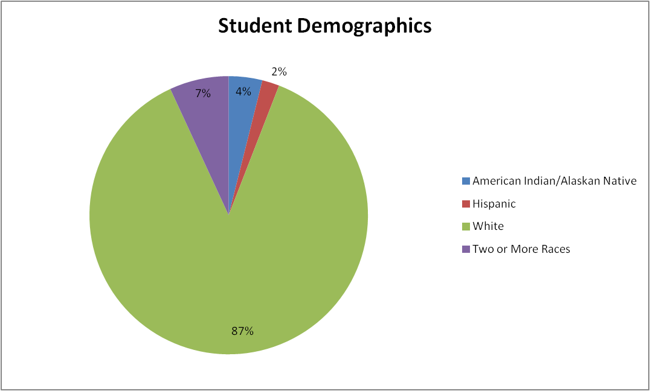

**Student Achievement Data**

Klickitat School uses the Washington “Measurement of Student Progress (MSP), a criterion referenced test, as an annual summative assessment for grades 3-8 in the areas of Reading and Math. Writing is assessed annually in grades 4, 7 and 10. The following graphs show the percent of Klickitat students at each grade level meeting or exceeding standard on the MSP in the past three years.

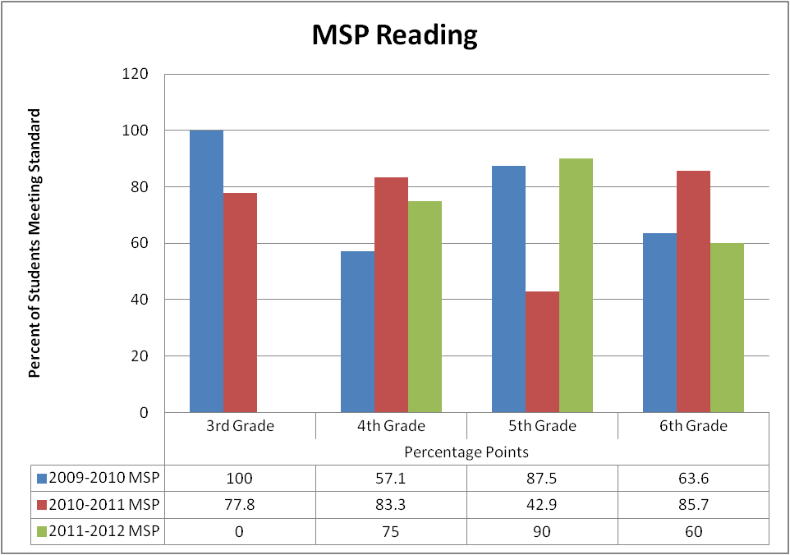

* The percent of 3rd grade Klickitat students meeting the standard in Reading has decreased by 22.2% from 2010 to 2011.
* The percent of 4th grade Klickitat students meeting the standard in Reading has increased by 17.9% from 2010 to 2012.
* The percent of 5th grade Klickitat students meeting the standard in Reading has increased by 2.5% from 2010 to 2012.
* The percent of 6th grade Klickitat students meeting standard in Reading has decreased by 3.6% from 2010-2012.

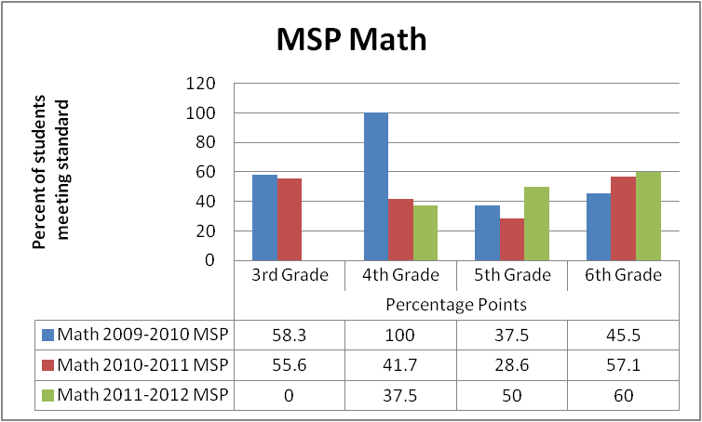

* The percent of 3rd grade Klickitat students meeting the standard in Mathematics has decreased by 2.7% from 2010 to 2011.
* The percent of 4th grade Klickitat students meeting the standard in Mathematics has decreased by 72.5% from 2010 to 2012.
* The percent of 5th grade Klickitat students meeting the standard in Mathematics has increased by 12.5% from 2010 to 2012.
* The percent of 6th grade Klickitat students meeting standard in Mathematics has increased by 14.5% from 2010-2012.

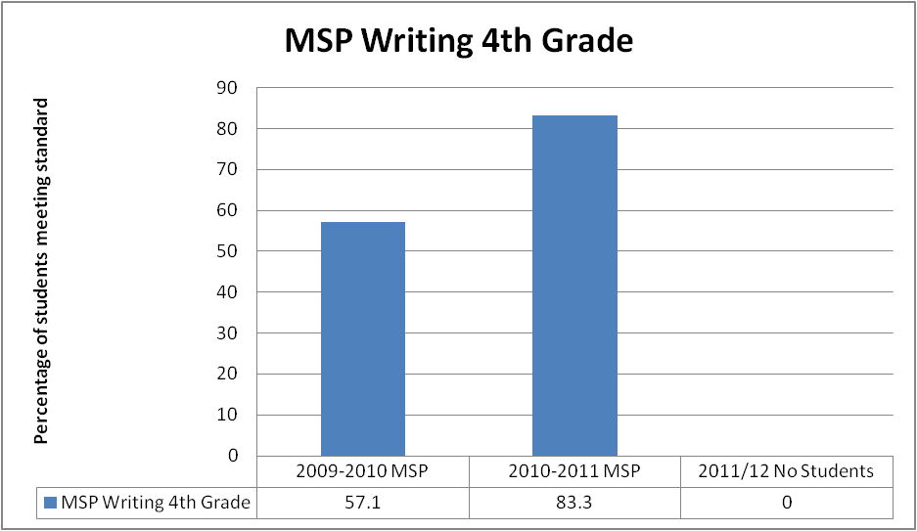

* The percent of 4th grade Klickitat students meeting the standard in Writing has increased by 26.2% from 2010 to 2011.

**State and District MSP**

Washington State uses the Measure of Student Progress (MSP) a criterion referenced test, at grades 3-8. This chart shows the percent of students meeting or exceeding standard in Reading, Writing and Math at the state and district level.

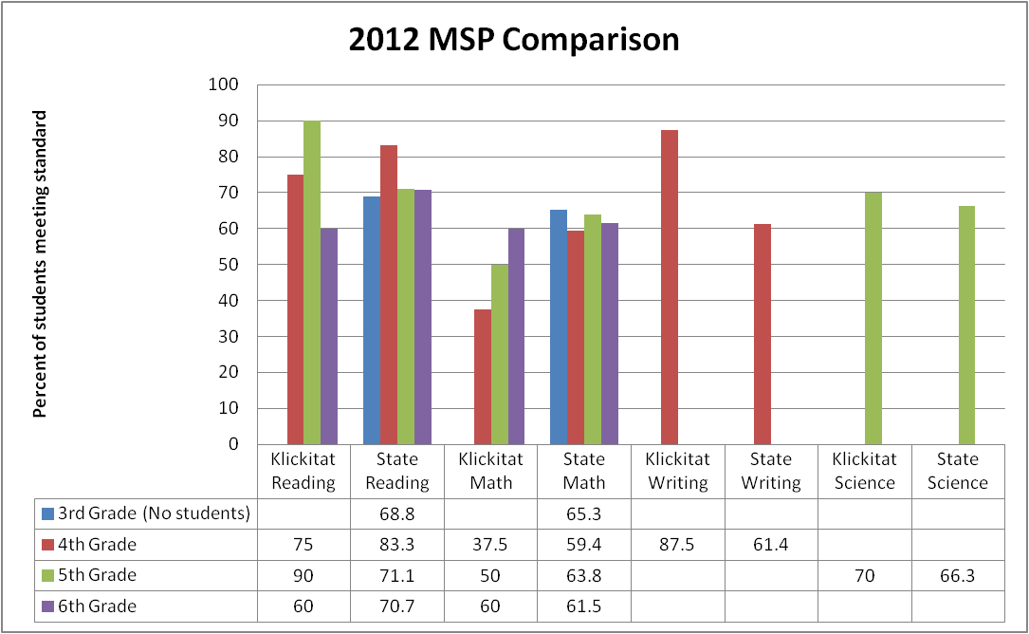

* Klickitat School has more grade 5 students meeting standard in Reading than the state in 2012.
* Klickitat School has fewer grade 4, 5, & 6 students meeting standard in Math than the state in 2012.
* Klickitat School has more grade 4 students meeting standard in Writing than the state in 2012.
* Klickitat School has more grade 5 students meeting standard in Science than the state in 2012.

**MSP Strand Scores**

“Strand” level information helps us focus on particular areas in each content area that might be a strength or weakness. To be valid, district strand scores must be compared to state performance. Strand data is based on a two year average where appropriate.

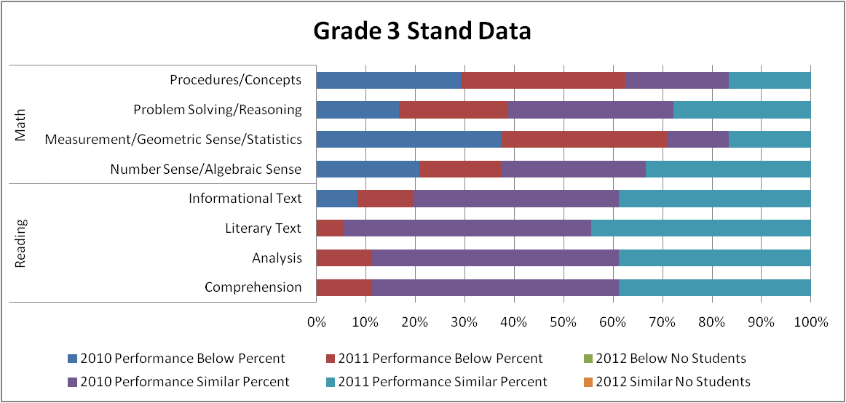

Math

* Procedures/Concepts – Klickitat grade 3 students performed at a lower percent average than similar state students
* Problem Solving/Reasoning – Klickitat grade 3 students perform at a higher percent average than similar state students.
* Measurement/Geometric Sense/Statistics – Klickitat grade 3 students perform at a lower percent average than similar state students.
* Number Sense/Algebraic Sense – Klickitat grade 3 students perform at a higher percent average than similar state students.

Reading

* Informational Text – Klickitat grade 3 students perform at a higher percent average than similar state students.
* Literary Text – Klickitat grade 3 students perform at a higher percent average than similar state students.
* Analysis – Klickitat grade 3 students perform at a higher percent average than similar state students.
* Comprehension – Klickitat grade 3 students perform at a higher percent average than similar state students.

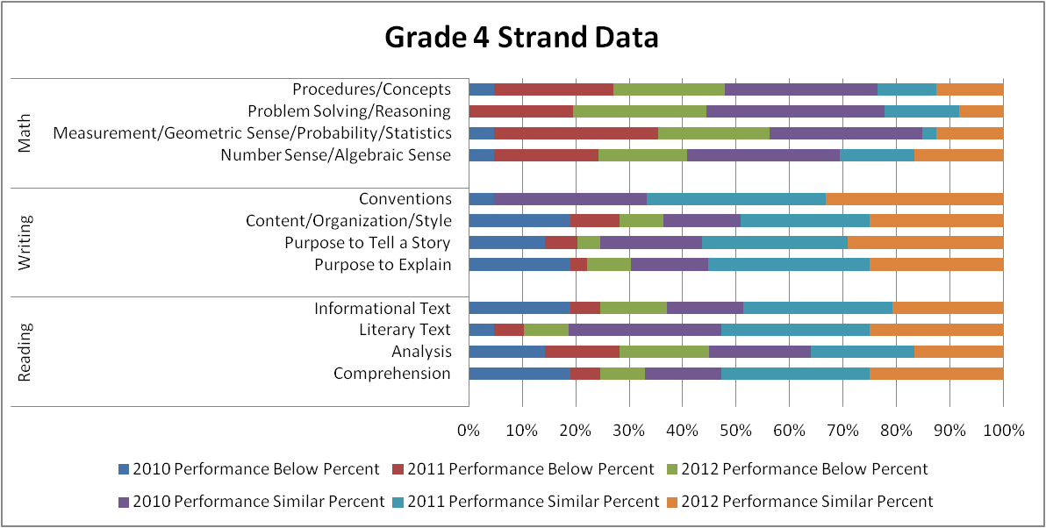

Math

* Procedures/Concepts – Klickitat grade 4 students performed at a higher percent average than similar state students
* Problem Solving/Reasoning – Klickitat grade 4 students perform at a higher percent average than similar state students.
* Measurement/Geometric Sense/Statistics – Klickitat grade 4 students perform at a lower percent average than similar state students.
* Number Sense/Algebraic Sense – Klickitat grade 4 students perform at a higher percent average than similar state students.

Writing

* Conventions – Klickitat grade 4 students performed at a higher percent average than similar state students
* Content/Organization/Style – Klickitat grade 4 students performed at a higher percent average than similar state students
* Purpose to Tell a Story – Klickitat grade 4 students performed at a higher percent average than similar state students
* Purpose to Explain – Klickitat grade 4 students performed at a higher percent average than similar state students

Reading

* Informational Text – Klickitat grade 4 students perform at a higher percent average than similar state students.
* Literary Text – Klickitat grade 4 students perform at a higher percent average than similar state students.
* Analysis – Klickitat grade 4 students perform at a higher percent average than similar state students.
* Comprehension – Klickitat grade 4 students perform at a higher percent average than similar state students.

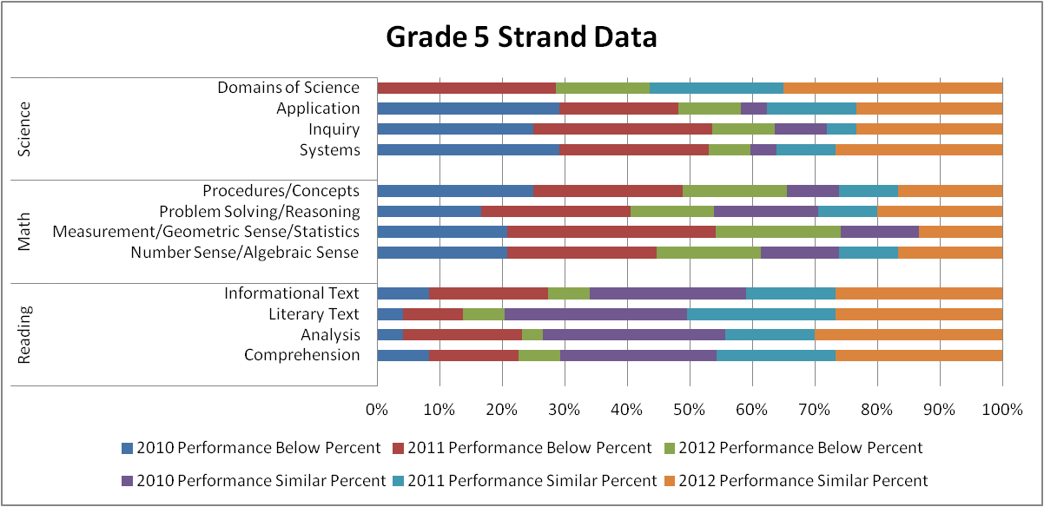

Science

* Domains of Science – Klickitat grade 5 students performed at a lower percent average than similar state students
* Application – Klickitat grade 5 students performed at a higher percent average than similar state students
* Inquiry – Klickitat grade 5 students performed at a lower percent average than similar state students
* Systems – Klickitat grade 5 students performed at a lower percent average than similar state students

Math

* Procedures/Concepts – Klickitat grade 5 students performed at a lower percent average than similar state students
* Problem Solving/Reasoning – Klickitat grade 5 students perform at a lower percent average than similar state students.
* Measurement/Geometric Sense/Statistics – Klickitat grade 5 students perform at a lower percent average than similar state students.
* Number Sense/Algebraic Sense – Klickitat grade 5 students perform at a lower percent average than similar state students.

Reading

* Informational Text – Klickitat grade 5 students perform at a higher percent average than similar state students.
* Literary Text – Klickitat grade 5 students perform at a higher percent average than similar state students.
* Analysis – Klickitat grade 5 students perform at a higher percent average than similar state students.
* Comprehension – Klickitat grade 5 students perform at a higher percent average than similar state students.

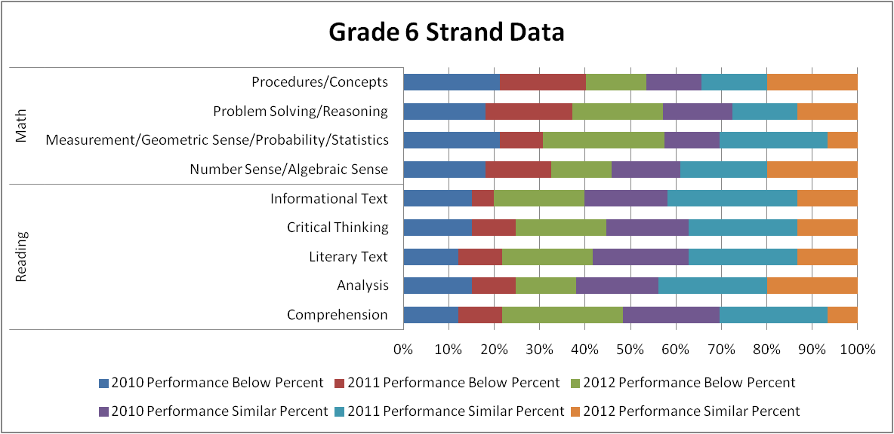

Math

* Procedures/Concepts – Klickitat grade 6 students performed at a lower percent average than similar state students
* Problem Solving/Reasoning – Klickitat grade 6 students perform at a lower percent average than similar state students.
* Measurement/Geometric Sense/Statistics – Klickitat grade 6 students perform at a lower percent average than similar state students.
* Number Sense/Algebraic Sense – Klickitat grade 6 students perform at a higher percent average than similar state students.

Reading

* Informational Text – Klickitat grade 6 students perform at a higher percent average than similar state students.
* Critical Thinking – Klickitat grade 6 students perform at a higher percent average than similar state students.
* Literary Text – Klickitat grade 6 students perform at a higher percent average than similar state students.
* Analysis – Klickitat grade 6 students perform at a higher percent average than similar state students.
* Comprehension – Klickitat grade 6 students perform at a higher percent average than similar state students.

**Annual Measurable Objective (AMO)**

|  |
| --- |
|  |

AMOs are unique yearly targets in reading and mathematics for each subgroup, school and district, as described in [Washington’s Elementary and Secondary Education Act (ESEA) Flexibility Request](http://www.k12.wa.us/ESEA/PublicNotice.aspx). AMOs replaces the state uniform bar used under Adequate Yearly Progress (AYP) as prescribed in ESEA. The Klickitat School **is not** a Reward, Priority, Focus, or Emerging School as identified by OSPI. The below chart is a summary of Klickitat schools AMO results for 2012.

|  |  |  |  |  |  |  |  |  |  |  |  |  |  |  |  |  |  |  |  |  |  |  |  |  |  |  |  |  |  |  |  |  |  |  |  |  |  |  |  |  |  |  |  |  |  |  |  |  |  |  |  |  |  |  |  |  |  |  |  |  |  |  |  |  |  |  |  |  |  |  |  |  |  |  |  |  |  |  |  |  |  |  |  |  |  |  |  |  |  |  |  |  |  |  |  |  |  |  |  |  |  |  |  |  |  |  |  |  |  |  |  |  |  |  |  |  |  |  |  |  |  |  |  |  |
| --- | --- | --- | --- | --- | --- | --- | --- | --- | --- | --- | --- | --- | --- | --- | --- | --- | --- | --- | --- | --- | --- | --- | --- | --- | --- | --- | --- | --- | --- | --- | --- | --- | --- | --- | --- | --- | --- | --- | --- | --- | --- | --- | --- | --- | --- | --- | --- | --- | --- | --- | --- | --- | --- | --- | --- | --- | --- | --- | --- | --- | --- | --- | --- | --- | --- | --- | --- | --- | --- | --- | --- | --- | --- | --- | --- | --- | --- | --- | --- | --- | --- | --- | --- | --- | --- | --- | --- | --- | --- | --- | --- | --- | --- | --- | --- | --- | --- | --- | --- | --- | --- | --- | --- | --- | --- | --- | --- | --- | --- | --- | --- | --- | --- | --- | --- | --- | --- | --- | --- | --- | --- | --- | --- | --- |
| |  | | --- | |  | | |  |  |  |  |  |  |  |  |  |  |  |  |  |  |  |  |  |  |  |  |  |  |  |  |  |  |  |  |  |  |  |  |  |  |  |  |  |  |  |  |  |  |  |  |  |  |  |  |  |  |  |  |  |  |  |  |  |  |  |  |  |  |  |  |  |  |  |  |  |  |  |  |  |  |  |  |  |  |  |  |  |  |  |  |  |  |  |  |  |  |  |  |  |  |  |  |  |  |  |  |  |  |  |  |  |  |  |  |  |  |  |  |  |  |  |  |  |  |  |  |  |  | | --- | --- | --- | --- | --- | --- | --- | --- | --- | --- | --- | --- | --- | --- | --- | --- | --- | --- | --- | --- | --- | --- | --- | --- | --- | --- | --- | --- | --- | --- | --- | --- | --- | --- | --- | --- | --- | --- | --- | --- | --- | --- | --- | --- | --- | --- | --- | --- | --- | --- | --- | --- | --- | --- | --- | --- | --- | --- | --- | --- | --- | --- | --- | --- | --- | --- | --- | --- | --- | --- | --- | --- | --- | --- | --- | --- | --- | --- | --- | --- | --- | --- | --- | --- | --- | --- | --- | --- | --- | --- | --- | --- | --- | --- | --- | --- | --- | --- | --- | --- | --- | --- | --- | --- | --- | --- | --- | --- | --- | --- | --- | --- | --- | --- | --- | --- | --- | --- | --- | --- | --- | --- | | |  |  |  |  |  |  |  |  |  |  |  |  |  |  |  |  |  |  |  |  |  |  |  |  |  |  |  |  |  |  |  |  |  |  |  |  |  |  |  |  |  |  |  |  |  |  |  |  |  |  |  |  |  |  |  |  |  |  |  |  |  |  |  |  |  |  |  |  |  |  |  |  |  |  |  |  |  |  |  |  |  |  |  |  |  |  |  |  |  |  |  |  |  |  |  |  |  |  |  |  |  |  |  |  |  |  |  |  |  |  |  |  |  |  |  |  |  |  |  |  |  | | --- | --- | --- | --- | --- | --- | --- | --- | --- | --- | --- | --- | --- | --- | --- | --- | --- | --- | --- | --- | --- | --- | --- | --- | --- | --- | --- | --- | --- | --- | --- | --- | --- | --- | --- | --- | --- | --- | --- | --- | --- | --- | --- | --- | --- | --- | --- | --- | --- | --- | --- | --- | --- | --- | --- | --- | --- | --- | --- | --- | --- | --- | --- | --- | --- | --- | --- | --- | --- | --- | --- | --- | --- | --- | --- | --- | --- | --- | --- | --- | --- | --- | --- | --- | --- | --- | --- | --- | --- | --- | --- | --- | --- | --- | --- | --- | --- | --- | --- | --- | --- | --- | --- | --- | --- | --- | --- | --- | --- | --- | --- | --- | --- | --- | --- | --- | --- | --- | --- | --- | --- | | |  |  |  |  |  |  |  |  |  | | --- | --- | --- | --- | --- | --- | --- | --- | --- | |  | Reading | | | Math | | | Reading | Math | | Student Group | Proficiency | Target | Met Target | Proficiency | Target | Met Target | Met 95% Participation Target | Met 95% Participation Target | | All | 68.9 | 72.2 | Below | 46.7 | 44.3 | On/Above | On/Above | On/Above | | American Indian |  |  | N<Required |  |  | N<Required | N<Required | N<Required | | Asian |  |  | No Students |  |  | No Students | No Students | No Students | | Pacific Islander |  |  | No Students |  |  | No Students | No Students | No Students | | Black |  |  | No Students |  |  | No Students | No Students | No Students | | Hispanic |  |  | N<Required |  |  | N<Required | N<Required | N<Required | | White | 68.4 | 71.4 | Below | 47.4 | 46.5 | On/Above | On/Above | On/Above | | Two or More Races |  |  | N<Required |  |  | N<Required | N<Required | N<Required | | Limited English |  |  | No Students |  |  | No Students | No Students | No Students | | Special Education |  |  | N<Required |  |  | N<Required | N<Required | N<Required | | Low Income | 68.9 | 68.6 | On/Above | 46.7 | 31.9 | On/Above | On/Above | On/Above | | |  | | --- | | Other Indicator | | On/Above | | | | |

* Klickitat schools met the all target categories with the exception of two.
* Student Group “All” is below the reading target by 3.3%.
* Student Group “White” is below the reading target by 3.0%.

**Annual Measurable Achievement Objectives (AMAOs)**

The Klickitat School District does not have any English Language Learners (ELL) students; therefore there is no data/need for AMAO’s.

**Other Sources of Student Achievement**

**MAP**

The Klickitat School District uses the Northwest Evaluation Association (NWEA) assessment program Measures of Academic Progress® (MAP®). MAP provides an MAP assessments provide detailed, actionable data about where each child is on their unique learning path. Because student engagement is essential to any testing experience, NWEA works with educators to create test items that interest children and help to capture detail about what they know and what they’re ready to learn.understanding of each student’s academic level and gives teachers the data to help them plan accordingly. MAP is a computerized adaptive assessment that makes it possible to provide educators with the detailed information they need to build curriculum and meet their students’ needs.



* 20% of students have a math growth index below zero but above the projected state standard proficiency.
* 20% of students have a math growth index below zero and also below the projected state standard proficiency.
* 36.7% of students have a math growth index above zero and also above the projected state standard proficiency.
* 23.3% of students have a math growth index above zero but below the projected state standard proficiency.



* 22.6% of students have a reading growth index below zero but above the projected state standard proficiency.
* 22.6% of students have a reading growth index below zero and also below the projected state standard proficiency.
* 48.8% of students have a reading growth index above zero and also above the projected state standard proficiency.
* 6.5% of students have a reading growth index above zero but below the projected state standard proficiency.

MAP assessments provide detailed, actionable data about where each child is on their unique learning path. Because student engagement is essential to any testing experience, NWEA works with educators to create test items that interest children and help to capture detail about what they know and what they’re ready to learn.MAP assessments provide detailed, actionable data about where each child is on their unique learning path. Because student engagement is essential to any testing experience, NWEA works with educators to create test items that interest children and help to capture detail about what they know and what they’re ready to learn.MAP assessments provide detailed, actionable data about where each child is on their unique learning path. Because student engagement is essential to any testing experience, NWEA works with educators to create test items that interest children and help to capture detail about what they know and what they’re ready to learn.

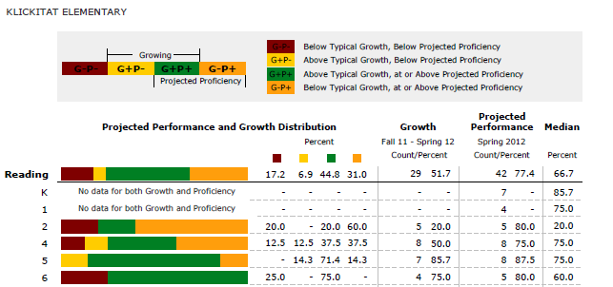

* School wide projected reading proficiency performance at 77.4%
* Grade 2 projected reading proficiency performance at 80.0%
* Grade 4 projected reading proficiency performance at 75.0%
* Grade 5 projected reading proficiency performance at 87.5%
* Grade 6 projected reading proficiency performance at 80.0%

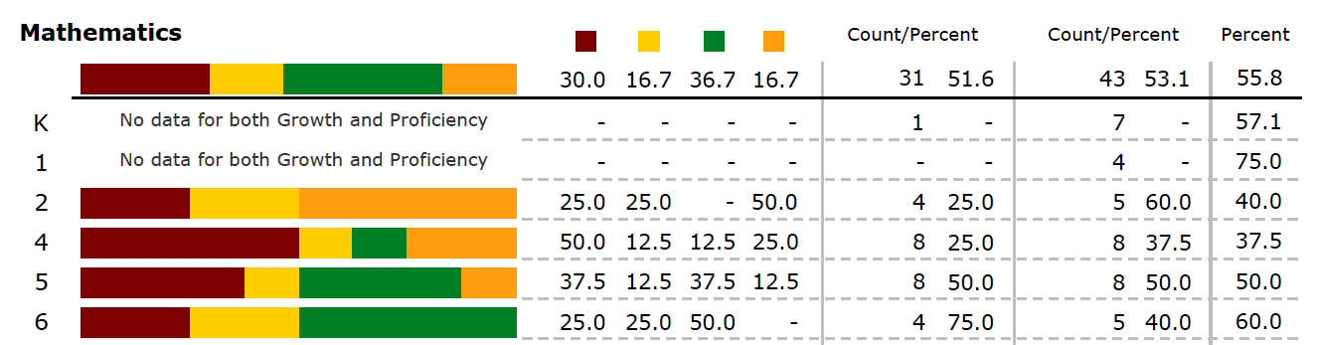

* School wide projected math proficiency performance at 53.1%
* Grade 2 projected math proficiency performance at 60.0%
* Grade 4 projected math proficiency performance at 37.5%
* Grade 5 projected math proficiency performance at 50.0%
* Grade 6 projected math proficiency performance at 40.0%

**STAR**

The STAR Math and STAR Reading Enterprise assessments include skills-based test items, and in-depth reports for screening, instructional planning, progress monitoring, standards benchmarking, as well as a Core Progress learning progression and Student Growth Percentile measurements. The Klickitat School District uses STAR Math & Reading in conjunction with the Renaissances Learning Accelerated Math and Accelerated Reading programs for all students K-12. The STAR Quartiles, Grade Equivalency (G.E.), and Instructional Reading Level (IRL) are all based on state standards from Fall 2011 to spring 2013.

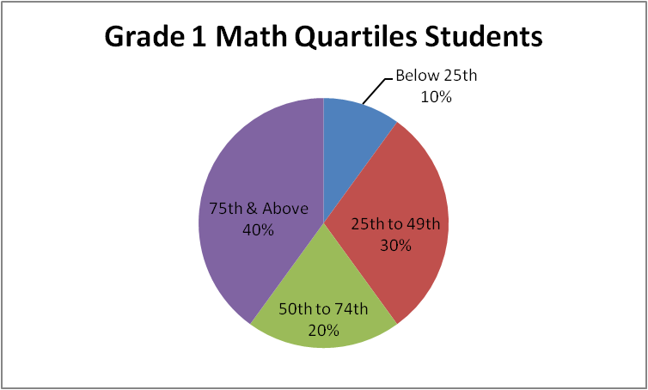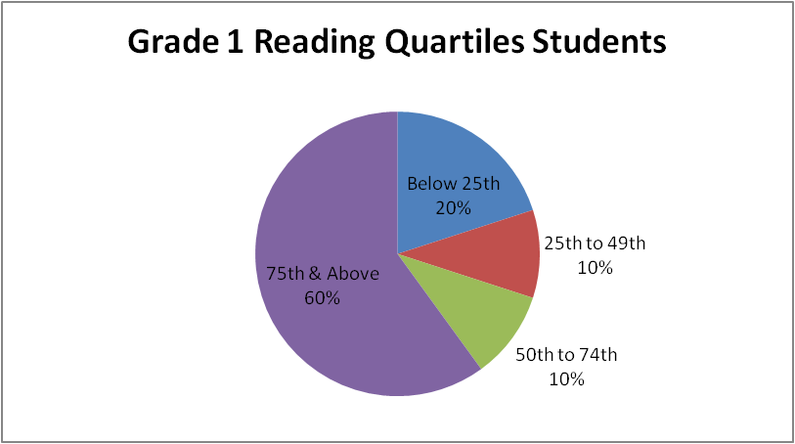

* 60% of Grade 1 students place in the top two math quartiles
* 70% of Grade 1 students place in the top two reading quartiles

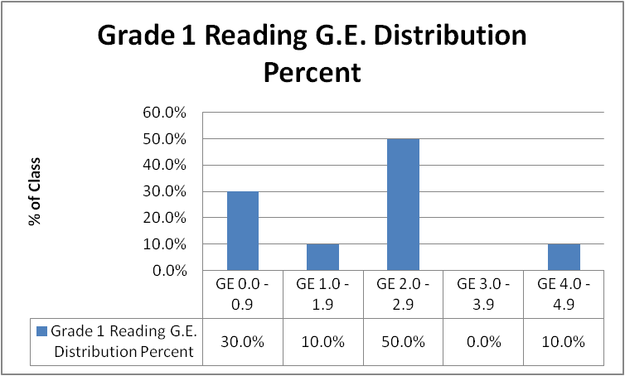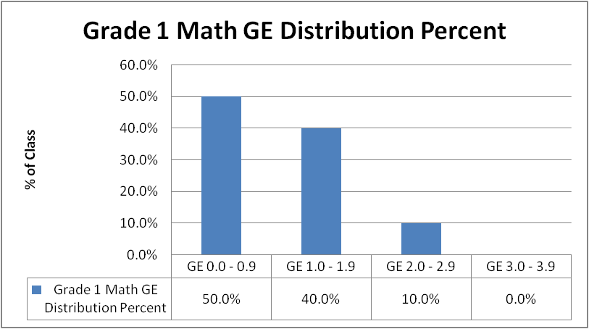

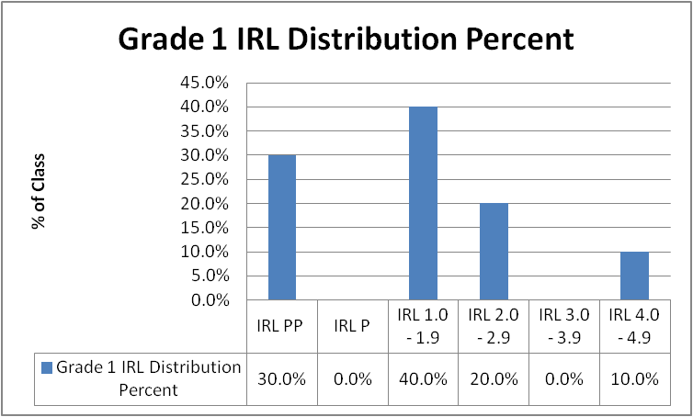

* 70% of Grade 1 students are reading at Grade 1.0 level or above
* 50% of Grade 1 students are performing math at Grade 1.0 level or above
* 70% of Grade 1 students Instructional Reading Level is at Grade 1.0 or above

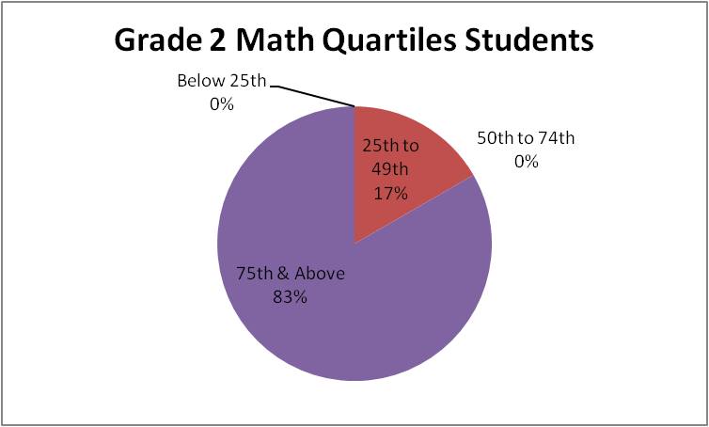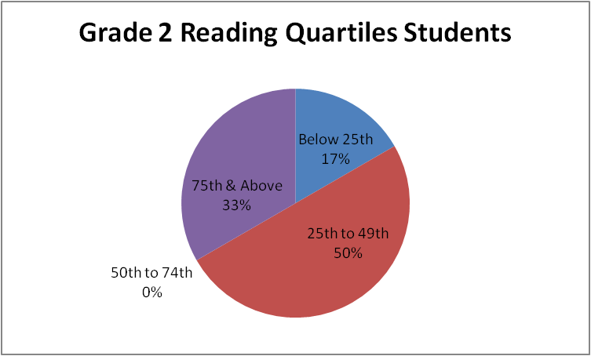

* 83% of Grade 2 students place in the top two math quartiles
* 33% of Grade 2 students place in the top two reading quartiles

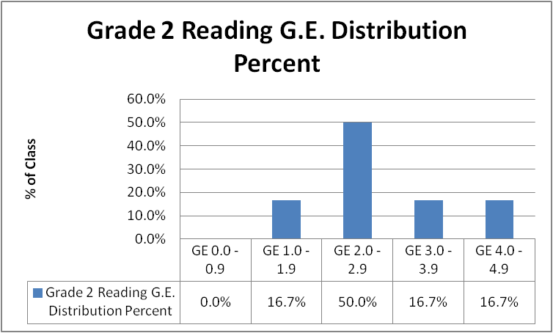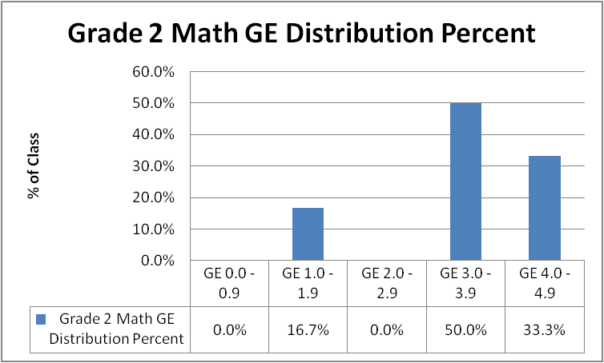

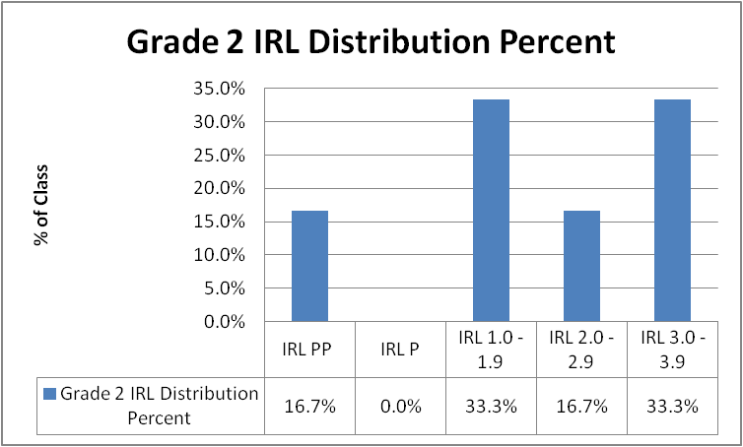

* 83.3% of Grade 2 students are reading at Grade 2.0 level or above
* 83.3% of Grade 2 students are performing math at Grade 2.0 level or above
* 50% of Grade 2 students Instructional Reading Level is at Grade 2.0 or above

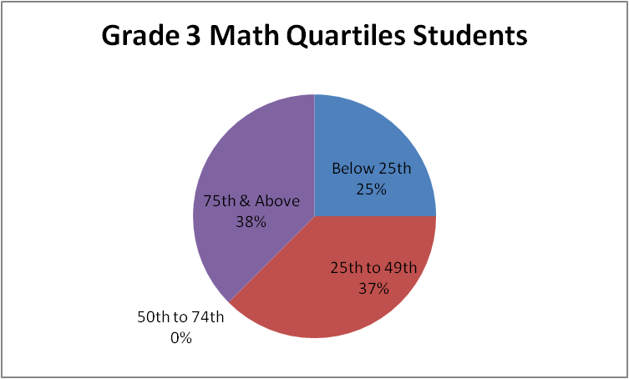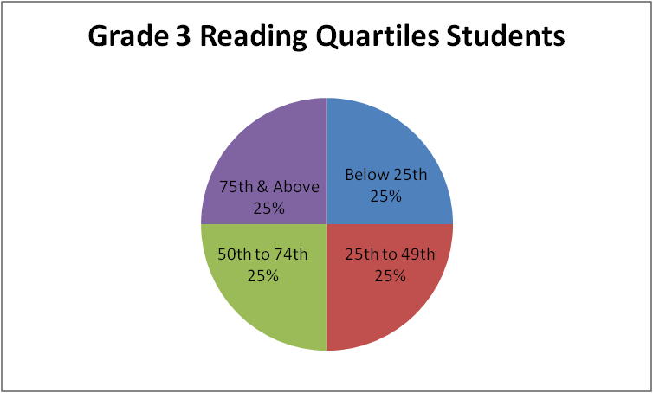

* 38% of Grade 3 students place in the top two math quartiles
* 50% of Grade 3 students place in the top two reading quartiles

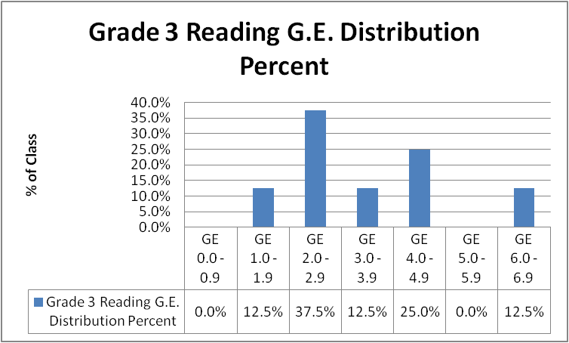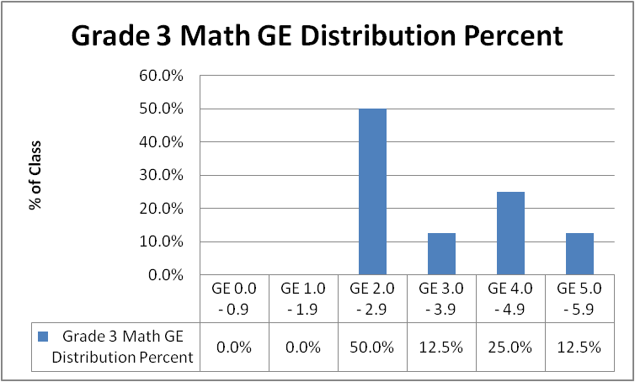

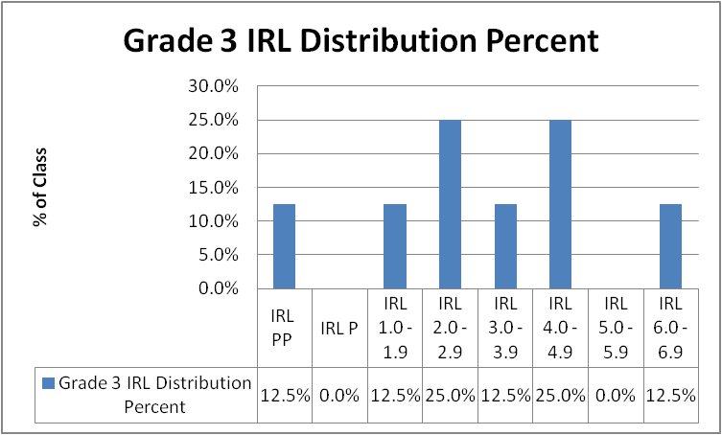

* 50% of Grade 3 students are reading at Grade 3.0 level or above
* 50% of Grade 3 students are performing math at Grade 3.0 level or above
* 50% of Grade 3 students Instructional Reading Level is at Grade 3.0 or above

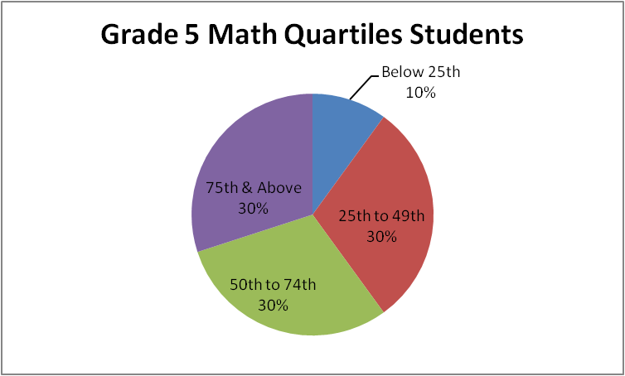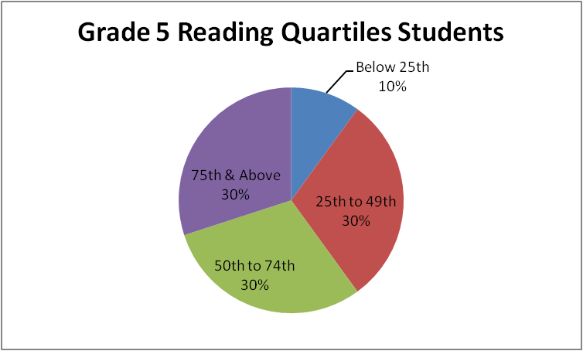

* 60% of Grade 5 students place in the top two math quartiles
* 60% of Grade 5 students place in the top two reading quartiles

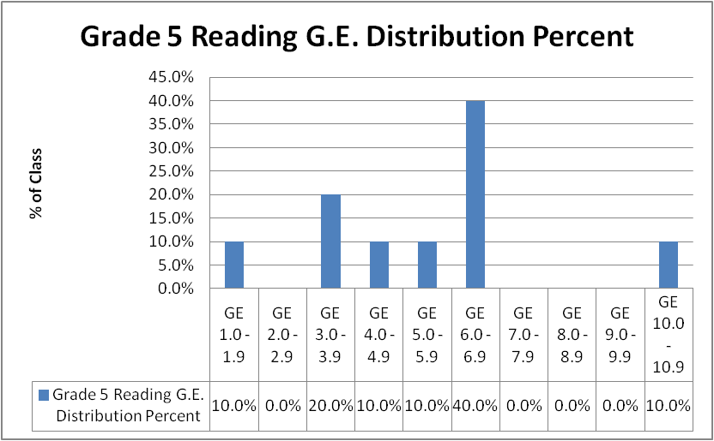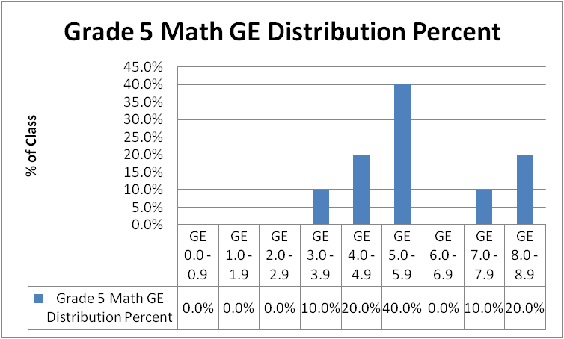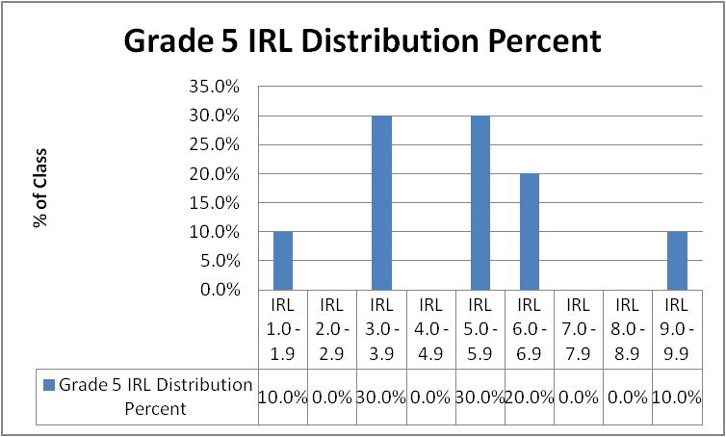

* 60% of Grade 5 students are reading at Grade 5.0 level or above
* 70% of Grade 5 students are performing math at Grade 5.0 level or above
* 60% of Grade 5 students Instructional Reading Level is at Grade 5.0 or above

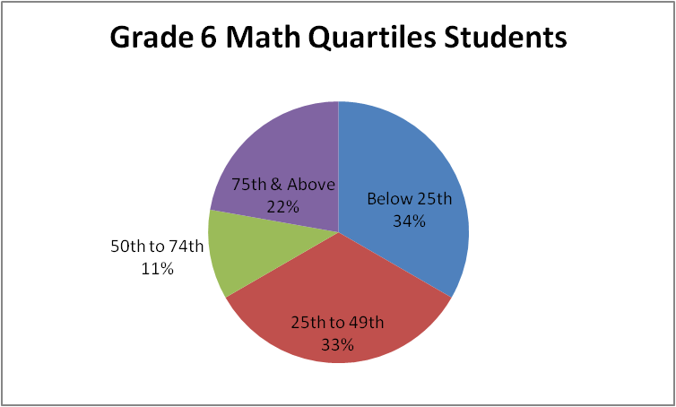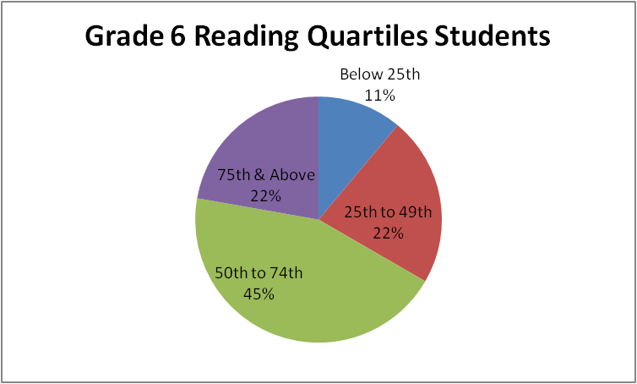

* 33% of Grade 6 students place in the top two math quartiles
* 67% of Grade 6 students place in the top two reading quartiles

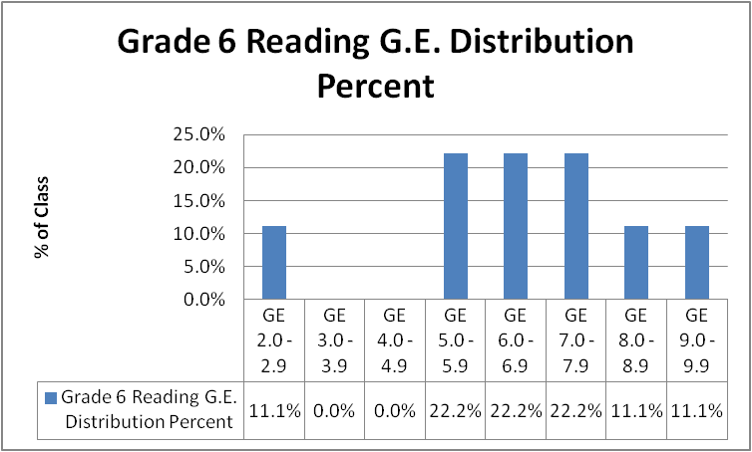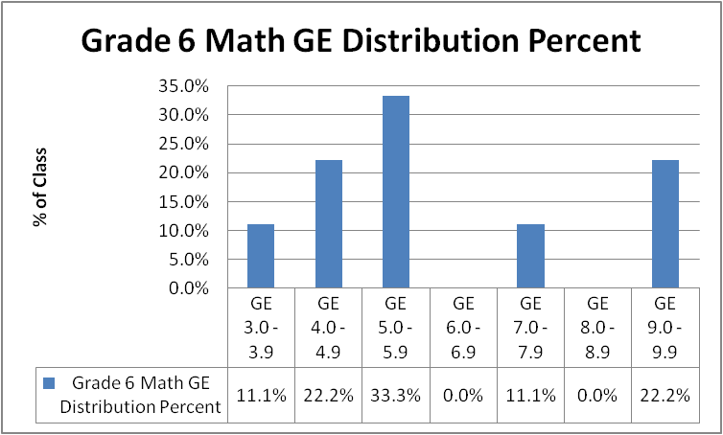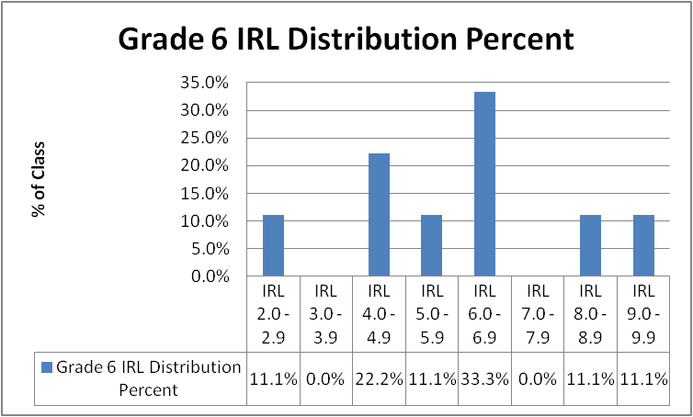

* 66.6% of Grade 6 students are reading at Grade 6.0 level or above
* 33.3% of Grade 6 students are performing math at Grade 6.0 level or above
* 55.5% of Grade 6 students Instructional Reading Level is at Grade 6.0 or above

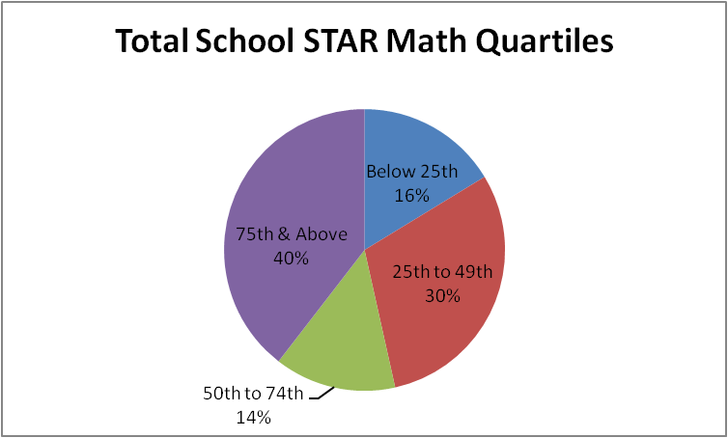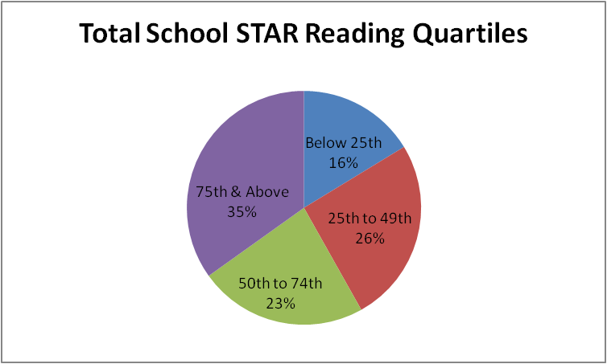

* 54% of all students place in the top two math quartiles
* 58% of all students place in the top two reading quartiles

Areas of Strength and Areas in Need of Improvement**:**

Based on data gathered from our needs assessment we have identified the following strengths and weaknesses of our current program.

**Student Achievement**

*Reading Strengths*:

* Informational Text – Klickitat grades 3-6 perform at a higher percent average than similar state students.
* Literary Text – Klickitat grades 3-6 students perform at a higher percent average than similar state students.
* Analysis – Klickitat grades 3-6 students perform at a higher percent average than similar state students.
* Comprehension – Klickitat grades 3-6 students perform at a higher percent average than similar state students.
* Critical Thinking – Klickitat grade 6 students perform at a higher percent average than similar state students.
* Projected Growth Index for all grades in reading is 54.9%
* School wide projected reading proficiency performance at 77.4%

*Reading Weaknesses*:

* Comprehension – Klickitat grade 6 students perform at a lower percent average than similar state students.
* 34% of all classes average below their Grade Equivalency in reading.
* Klickitat Schools is below their AMO target for group “All” by 3.3% and group “White” by 3.0%.

*Math Strengths*:

* Procedures/Concepts – Klickitat grade 4 students performed at a higher percent average than similar state students
* Problem Solving/Reasoning – Klickitat grades 3 & 4 students perform at a higher percent average than similar state students.
* Number Sense/Algebraic Sense – Klickitat grades 3, 4, & 6 students perform at a higher percent average than similar state students.
* Projected Growth Index for all grades in math is 60%

*Math Weaknesses*:

* Procedures/Concepts – Klickitat grades 3-6 students performed at a lower percent average than similar state students
* Problem Solving/Reasoning – Klickitat grades 4-6 students perform at a lower percent average than similar state students.
* Measurement/Geometric Sense/Statistics – Klickitat grade 3-6 students perform at a lower percent average than similar state students.
* Number Sense/Algebraic Sense – Klickitat grades 4 & 5 students perform at a lower percent average than similar state students.
* 43% of all classes average below their Grade Equivalency in math.
* School wide projected math proficiency performance at 53.1%.

*Writing Strengths*:

* Conventions – Klickitat grade 4 students performed at a higher percent average than similar state students.
* Content/Organization/Style – Klickitat grade 4 students performed at a higher percent average than similar state students.
* Purpose to Tell a Story – Klickitat grade 4 students performed at a higher percent average than similar state students.
* Purpose to Explain – Klickitat grade 4 students performed at a higher percent average than similar state students.

*Writing Weaknesses*:

* 12.5% of students have failed to meet state standards in writing.

1. **Schoolwide Reform Strategies (SWP Component 2) /Strategies to Ensure Assistance to Students of Need (SWP Component 9)**

**a. 2012 Schoolwide Goals**

The table below shows the Annual Measureable Objectives for the Klickitat School District. The minimum amount of the growth target goal for math and reading will be the percentage of increment and yearly target as indicated by the AMO table. Writing goal is based on a two year average of the percentage of students meeting the MSP standard and then a prorated precentage over the next five years to 100% of students meeting MSP writing standards in 2017.

Writing Target Annual Measurable Objectives (WTAMO’s)



Math & Reading Annual Measurable Objectives (AMO’s)



**READING GOAL**

All (100%) students at Klickitat School will be proficient in reading fiction and non-fiction by the year 2017 as measured by meeting AMO’s and the standard on the MSP Reading Assessment.

|  |  |  |  |  |
| --- | --- | --- | --- | --- |
| Reading | **Grade 3** | **Grade 4** | **Grade 5** | **Grade 6** |
| 2012 MSP %* | No Students | 75.0% | 90% | 60% |
| 2012 Target % | 71.1% | 71.1% | 71.1% | 71.1% |
| Difference | N.A. | +3.9% | +19.9% | -11.1% |
| Increment/Year | +2.6% | +2.6% | +2.6% | +2.6% |
| ***Growth Goal %*** | ***+2.6%*** | ***+2.6%*** | ***+2.6%*** | ***+13.7%*** |
| 2013 Target %* | 73.7% | 77.6% | 92.6% | 73.7% |

*Percent meeting standard on the MSP Reading Assessment

**MATH GOAL**

All (100%) students at Klickitat School will be proficient in mathematical process and content by the year 2017 as measured by AMO’s and meeting the standard on the MSP Mathematics Assessment.

|  |  |  |  |  |
| --- | --- | --- | --- | --- |
| Math | **Grade 3** | **Grade 4** | **Grade 5** | **Grade 6** |
| 2012 MSP %* | No Students | 37.5% | 50% | 60% |
| 2012 Target % | 43.7% | 43.7% | 43.7% | 43.7% |
| Difference | N.A. | -6.2% | +6.3% | +16.3% |
| Increment/Year | +5.1% | +5.1% | +5.1% | +5.1% |
| ***Growth Goal %*** | ***+5.1%*** | ***+11.3%*** | ***+5.1%*** | ***+5.1%*** |
| 2013 Target %* | 43.7% | 48.8% | 55.1% | 65.1% |

*Percent meeting standard on the MSP Mathematics Assessment

**WRITING GOAL**

All (100%) students at Klickitat School will be proficient in writing to a variety of audiences for a variety of purposes by the year 2014 as measured by meeting standard on the MSP Writing Assessment.

|  |  |  |  |  |
| --- | --- | --- | --- | --- |
| Writing | **Grade 3** | **Grade 4** | **Grade 5** | **Grade 6** |
| 2012 MSP %* |  | 87.5% |  |  |
| 2012 Target % |  | 88.9% |  |  |
| Difference |  | -1.4% |  |  |
| Increment/Year |  | +2.2% |  |  |
| ***Growth Goal %*** |  | ***+3.6%*** |  |  |
| 2013 Target %* |  | 91.1% |  |  |

*Percent meeting standard on the WASL Writing Assessment

##### b. Instructional Program

The Klickitat Elementary School instructional program consists of three multi-graded classrooms. The kindergarten/first grade classroom has 16 students, the second/third grade classroom has 14 students, there are no students in the fourth grade, and fifth/sixth grade has 18 students. Headstart is also housed within the elementary building. Because of a low pupil to teacher ratio, individual student strengths and weaknesses are known to teachers and paraeducators and interventions occur on a regular basis.

Curriculum and instruction is focused on grade level Essential Academic Learning Requirements, (EALRs), district and state benchmarks, and the Grade Level Expectations (GLEs). Textbook adoptions, as well as all other instructional resources, are aligned with these educational benchmarks and standards. Scientifically research-based instruction and interventions are delivered with fidelity in general, remedial and special education. These programs include Read Naturally, to build fluency; Read Well to increase decoding, vocabulary and comprehension skills; Waterford Early, an intentional teaching of vocabulary and comprehension skills; Investigations Mathematics and Step-up To Writing.

##### Accountability /Teacher Participation in Assessment Decisions (SWP Component 8)

The assessments listed below are used to inform and guide instruction, as well as monitor student progress and evaluate student success. They are also used to ensure that progress toward reaching our goals takes place and if the implementation of the schoolwide program is working and/or needs to be adjusted.

Grade level teams of general education teachers and specialists meet monthly to determine the success of individual students within their program. Data drives instruction and placement decisions, as well as professional development and decisions about resources and materials.

* **MSP**

All students in grades 3-8 take the Washington Measurement of Student Progress in Reading and Mathematics, in Writing in grade 4, and in Science in grade 7. This is used as a summative assessment and evidence of meeting our Schoolwide goals.

* **MAP**

All students in grades K-10 take the Northwest Evaluation Association MAP reading and math assessment three times a year; fall, winter, and spring. MAP provides an MAP assessments provide detailed, actionable data about where each child is on their unique learning path. Because student engagement is essential to any testing experience, NWEA works with educators to create test items that interest children and help to capture detail about what they know and what they’re ready to learn.understanding of each student’s academic level and gives teachers the data to help them plan accordingly. MAP is a computerized adaptive assessment that makes it possible to provide educators with the detailed information they need to build curriculum and meet their students’ needs.

* **STAR**

Students in grades K-6 take this norm referenced assessment to assess reading & math levels and grade equivalency of students. The results are used to determine the appropriate level of challenge for each student and to personalize practice and individualized learning through the Renaissance Learning Accelerated Reading & Accelerated Math programs

* **QRI**

Second grade students are given an individually administered assessment to determine their fluency and accuracy in reading. For all qualifying students, parents and teachers work together to develop an Individualized Plan for improving their reading skills. This plan includes a home component as well as the school-based intervention.

* **Textbook Adopted Curriculum Assessments in Reading and Math**

These are assessments that accompany textbook adoptions, and are given as a pre and/or post chapter or unit of study measure of student academic growth and progress.

* **Writing Prompts**

Grade level prompts, developed and scored by Klickitat teachers, are administered three times a year and used for progress monitoring.

**d. Action Plans**

|  |  |  |  |  |  |  |  |  |  |  |  |  |
| --- | --- | --- | --- | --- | --- | --- | --- | --- | --- | --- | --- | --- |
| **SCHOOLWIDE ACTION PLAN**  **KLICKITAT ELEMENTARY SCHOOL K-6**  **KLICKITAT SCHOOL DISTRICT #402** | | | | | | | | | | | | |
| **Schoowide Improvement Goal #1: All (100%) students at Klickitat School will be proficient in mathematical process and content by the year 2017 as** | | | | | | | | | | | | |
| **measured by AMO’s meeting the standard on the MSP Mathematics Assessment.** | | | | | | | | | | |  |  | |  |  |  |
|  | |  | |  |  | | |  | |  | | |
| **Activities to Achieve this Goal:** | | **Professional**  **Development** | | **Timeline** | **Resources Available** | | | **Who Is Responsible?** | | **Monitoring**  **Effectiveness** | | |
| Familiarize students with math vocabulary | | Identify mathematical vocabulary focus for each grade | | School Year 2012-13 | Early Release/In-service | | | Classroom Teachers  Paraeducators | | Vocabulary identified  Student work samples | | |
| Collect, graph and analyze student achievement data for those receiving math interventions | | Determine tools already in use and gather data | | School year 2012-13 | Early Release/In-service | | | Classroom Teachers Paraeducators | | MAP Assessments  STAR Math Assessments | | |
| Students K-6 Accelerated Math program | | Program development and implementation | | School year 2012-13 | Early Release/In-service District funds | | | Classroom Teachers Paraeducators | | MAP Assessments  STAR Math Assessments | | |
| Rocket Math Facts | | Program development and implementation | | School year 2012-13 | Early Release/In-service District funds | | | Classroom Teachers Paraeducators | | Rocket Math Assessments | | |
| High quality core instruction in mathematics | | Mathematical Content training for teachers and paraeducators | | Spring 2013 | District funds | | | Klickitat District Math Coordinator  Principal | | Classroom evidence of research based instruction in mathematical content | | |
| Transition to revised C.C.S.S. math standards | | Revised Math Standards training | | Summer 2013 | District funds | | | Klickitat District Math Coordinator  Principal | | Revised math standards drive instruction | | |
| Investigate recommended C.C.S.S. mathematical materials | | Materials Showcase | | Summer 2013 | District funds | | | Klickitat District Math Coordinator  Principal | | Recommendation | | |
| Determine intervention materials in mathematics | | Interventional Materials Showcase | | Summer 2013 | District funds | | | Klickitat District Math Coordinator  Principal | | Recommendation | | |
| Afterschool Program for students in grades 5/6 | |  | | 3 days per week all year | REACH Afterschool funds | | | Classroom teachers and REACH Staff | | Classroom performance | | |
| **Procedures for evaluating success in reaching this goal:** | | | | | | | | | | | | |
| The elementary staff is expected to document progress toward implementing this goal. They will review on a quarterly basis progress that has been made as evidenced by the monitoring tools. Strengths are celebrated and challenges addressed. | | | | | | | | | | | | |
|  | | | | | | | | | | | | |
|  | | | | | | | | | | | | |
| **Schoolwide Improvement Goal #2: All (100%) students at Klickitat School will be proficient in writing to a variety of audiences for a variety of purposes by the year 2017 as measured by the WTAMO’s(established by district) meeting standard on the MSP Writing Assessment.** | | | | | | | | | | | | |
|  | |  |  | | |  |  | |  | | | |
| **Activities to Achieve this Goal:** | | **Professional**  **Development** | **Timeline** | | | **Resources Available** | **Who Is Responsible?** | | **Monitoring**  **Effectiveness** | | | |
| Analyze data from writing prompts | Review scoring criteria | | School Year 2012-13 | | | Early Release | Teachers | | Data analyzed  Instruction Informed | | | |
| Develop additional writing prompts | Review prompt criteria | | Spring 2013 | | | Early Release | Teachers | | Prompts written | | | |
| Assess amount of time spent on the teaching and practice of improving content, organization and style. | Review of content, organization and style components | | Winter 2012-13 | | | Early Release | Teachers | | Record of time spent on teaching COS | | | |
| Provide authentic writing experiences. | Develop writing experiences connected to other content areas and the real world. | | Spring 2012 | | | Early Release | Teachers | | Analysis and development of writing activities | | | |
| Afterschool Program for students in grades 5/6 |  | | 3 days per week all year | | | REACH Afterschool funds | Classroom teachers and REACH Staff | | Classroom performance | | | |
| **Procedures for evaluating success in reaching this goal:** | | | | | | | | | | | | |
| The elementary staff is expected to document progress toward implementing this goal. They will review on a semester basis progress that has been made as evidenced by the monitoring tools. Strengths are celebrated and challenges addressed. | | | | | | | | | | | | |
|  | | | | | | | | | | | | |
|  | | | | | | | | | | | | |
| **Schoolwide Improvement Goal #3: All (100%) students at Klickitat School will be proficient in reading fiction and non-fiction by the year 2017 as measured by AMO’s meeting the standard on the MSP Reading Assessment.** | | | | | | | | | | | | |
|  |  | |  | | |  |  | |  | | | |
| **Activities to Achieve this Goal:** | | **Professional Development** | | **Timeline** | **Resources Available** | | | **Who Is Responsible?** | | **Monitoring** | | |
| Collect, graph and analyze student achievement data for those receiving reading interventions | | Determine tools already in use and gather data | | Winter 2012-13 | Early Release | | | Classroom Teachers and Paraeducators | | MAP Assessments  STAR Math Assessments | | |
| Students K-6 Accelerated Reading Program | | Program development and implementation | | School Year 2012-13 | Early Release/Inservice District Funds | | | Classroom Teachers and Paraeducators | | STAR Reading | | |
| Students K-6 Reading incentives reward program | | Program development and implementation | | School Year 2012-13 | Early Release/Inservice District Funds | | | Classroom Teachers Principal | | STAR Reading | | |
| 15 minutes of SSR reading time for K-6 students and staff | |  | | Daily, all year | Classroom collections  Library | | | Students and staff | | Observation | | |
| Afterschool Program for students in grades 5/6 | |  | | 3 days per week all year | REACH Afterschool funds | | | Classroom teachers and REACH Staff | | Classroom performance | | |
| **Procedures for evaluating success in reaching this goal:** | | | | | | | | | | | | |
| The elementary staff is expected to document progress toward implementing this goal. They will review on a semester basis progress that has been made as evidenced by the monitoring tools. Strengths are celebrated and challenges addressed. | | | | | | | | | | | | |
|  | | | | | | | | | | | | |
|  | | | | | | | | | | | | |

**4. Instruction by Highly Qualified Teachers and Paraprofessionals and Strategies to Attract Highly Qualified Teachers (SWP Components 3 and 5)**

All staff meet the state and federal guidelines for Highly Qualified. We hire highly qualified teachers who have specific endorsements and appropriate certificates to teach in the areas assigned, including a preference for teachers with Master degrees. Klickitat School District enjoys a very low attrition rate of its highly qualified staff. However, strategies to hire and retain the most highly qualified staff include:

* Proactively identifying future needs
* Advertizing nationally and locally
* Maintaining a large quality applicant pool from which to select personnel
* Building relationships with universities and colleges
* Identifying students with an interest in education and cultivating their interest

**5. Professional Development (SWP Component 4)**

On-going professional development opportunities that directly support program goals are provided to all staff. Professional development focuses on state standards, research based instructional practices and materials, and formative and summative assessment in reading, mathematics and writing.

Staff development opportunities are supported in the following ways:

* Collaborative time - Wednesday early release
* Staff meetings
* State and regional conferences and workshops
* Release time provided by substitutes

##### 6. Parent, Family and Community Participation (SWP Component 6)

The Klickitat staff believes that parent, family and community participation is an integral part of the total school program. As the perception surveys indicate, the staff maintains strong family and community involvement. Klickitat will continues with the activities that have made for this strong partnership, as well as increase the number of activities that focus directly on strategies to improve the reading, math and writing skill of their students. Keeping parents informed of their children’s strengths and weaknesses in these areas and their growth as evidenced by progress monitoring instruments will be a priority. (See Klickitat Elementary School Parent Involvement Policy/Plan that follows).

|  |  |  |  |  |  |  |  |  |  |  |  |
| --- | --- | --- | --- | --- | --- | --- | --- | --- | --- | --- | --- |
| **School Improvement Goal #4: Klickitat Elementary will maintain and improve an effective partnership between parents and the school.** | | | | | | | | | | | |
|  | | | | |  | | | | | | | |  |  |  |  |
|  | |  | |  | | |  | |  | |  |
| **Activities to Achieve this Goal:** | **Outcome** | | **Timeline** | | | **Resources Available** | | **Who Is Responsible?** | | **Monitoring** | |
| Open House | Explain Title I, Part A requirements | | Fall | | |  | | Superintendent  Principal  Teachers | | Agenda  Sign-ins  Evaluations | |
| Parent-Teacher Conferences | Information on curriculum, assessment of student progress and student expectations shared. Student compact agreed upon. | | Fall, Spring, As requested by parent or teacher | | |  | | Principal  Teachers | | Teacher records  Signed compacts | |
| Family Nights:  Career planning Literacy (Math & Reading) Nights | Students and parents engage in reading and mathematic activities | | Fall, Winter, Spring | | | District Funds REACH  GEAR-UP | | Principal  Teachers | | Agendas  Sign-ins  Evaluations | |
| Advisory Group Committee | Involvement in the Schoolwide Improvement Plan and Parent Involvement Plan/Policy | | Fall  Spring | | | ESD 112 | | Superintendent  Principal | | Agendas  Surveys  SWP  Parent Involvement Plan/Policy | |
| Parent Teacher Organization Meetings | Partnership in the educational process | | Monthly Meetings | | |  | | Teachers, Principal, Superintendent | | Agenda  Sign-ins | |
| **Procedures for evaluating success in reaching this goal:** | | | | | | | | | | | |
| The elementary staff is expected to document progress toward implementing this goal. They will review on a semester basis progress that has been made as evidenced by the monitoring tools. Strengths are celebrated and challenges addressed. | | | | | | | | | | | |
|  | | | | | | | | | | | | | | | | | |  |
|  | | | | | | | | | | | | | | | | | |  |

**KLICITAT SCHOOL DISTRICT**

**TITLE I STAFF, PARENT, AND STUDENT COMPACT**

**Student Name:____________________________ Date: _________________**

The Klickitat School District holds the following expectations of students, staff, and parents/guardians in order to provide for a learning climate that holds the maximum possibility for student achievement:

**Students:**

* Demonstrate respect for all persons in the school community – staff, parents, visitors, and other students.
* Come to school/class every day, on time, prepared to learn and achieve at the highest levels.
* Learn what you are expected to know and do.
* Do your best work at all times and ask for help when you need it.
* Read, understand, and commit to following this handbook and your school rules.
* Support my education in the following ways: _______________________________________

Signature: ________________________________________

**Staff:**

* Demonstrate respect for all persons in the school community – students, parents, visitors, and other staff.
* Begin school/class on time every day with purposeful activities.
* Set clear expectations for student achievement and behavior.
* Teach what students are expected to know and do.
* Communicate regularly with each student and parent regarding student progress and achievement, especially as this relates to graduation requirements.
* Read and understand this handbook and your local school rules.
* Develop a partnership with parents and the student to support the student’s education in the following ways: ______________________________________________________________

Signature: ________________________________________

**Parents/Guardians:**

* Demonstrate respect for all persons in the school community – students, staff, and other parents.
* Send your student to school/class every day on time and prepared to learn.
* Oversee your student’s work and always expect his/her best work.
* Communicate regularly with the teacher regarding your student’s progress and achievement.
* Read and understand this handbook and your school rules. Require your students to abide by these rules and regulations.
* Know that your student is on course for graduation.
* Develop a partnership with the teacher to support your student’s education in the following ways: ______________________________________________________________________

Signature: _______________________________________

**7. Plans for Transition and Coordination (SWP Component 7)**

The Klickitat School District and local Head Start program work closely to develop a seamless transition for young children into the Klickitat school system. The Klickitat Head Start is housed in the same building as the district’s K-6 students. Thus, there is routine sharing of several resources. This arrangement encourages frequent communication and facilitates a smooth transition for both students and parents to kindergarten. Head Start students are invited to spend a day in the kindergarten classroom as a part of “Kindergarten Round-Up” and are involved in school performances and assemblies as appropriate.

Coordination with seventh grade receiving teachers takes place formally both at the beginning and the end of each year. Communication takes place throughout the year due to the fact that both are located in the same building.

Coordination and communication also occurs with, Fort Vancouver Regional Library, Parks and Rec, American Youth Soccer Organization, Little Dribblers, Little League, Scouts, and Scholastic Book Fairs. Klickitat Elementary actively recruits and publish information about these outside agencies and program activities in the school newsletter. Flyers regarding community events are posted and distributed. Intentional planning occurs with the library for the purposes of school literacy events, as well as with the Washington Reading Corps program to provide additional learning opportunities for identified students.

Additional programs, grants, or new agency connections are evaluated by the leadership team prior to being approved for incorporation into the plan. This evaluation is based on the program, grant, or agency’s ability to meet the goals of our Schoolwide plan.

**8.** **Coordination of Federal, State and Local Services (SWP Component 10)**

|  |  |  |  |
| --- | --- | --- | --- |
| **Funding Source** | | **Amount Contributed** | **How funds will support**  **Schoolwide Program goals** |
| **Local funding sources:** | | |
| Local Levy |  |  |
|  |  |  |
| **State funding sources:** | | |
| Basic Education | $26,600.00 | Personnel cost to support instructional assistants assigned to implement the SW plan. |
| LAP |  |  |
|  |  |  |
| **Federal funding sources** | | |
| Title I, Part A: | $52,570.00 (includes carryover) | Personnel cost to support instructional assistants assigned to implement the SW plan. |
| Title I, Part C: |  |  |
| Title II, Part A: |  |  |
| Title II, Part D: |  |  |
| Title III: |  |  |
| Title IV, Part A |  |  |
| Title IV, Part B |  |  |
| Title V |  |  |
| Title VII |  |  |
| Title VIII |  |  |
| Title X |  |  |
| IDEA, Part B(*) |  |  |
| Carl Perkins |  |  |
|  |  |  |

(*) Amount restricted to proportion of funding for students with disabilities attending the schoolwide campus.

**Uses of Funds**

1. Provide a brief budget narrative explaining how funds listed in the table above will be used to support the schoolwide plan.

The two funding sources identified in Klickitat Elementary’s schoolwide plan are state basic education and Title I, A. These funds are used in the schoolwide plan to enhance the core education program and focus on increasing reading, writing, and math skills of students K-6th grade. Specifically, the funds will support direct services provided by paraprofessionals as well as the purchase of select researched based reading intervention materials.

**Appendices**